**Note: In this guide, we will be using postman as an example but the url used for the api call should be what you use to call the api.**

These are the URLs to call the API:

<http://54.221.121.199/registerUser> <- HTTP REQUEST: **POST**

<http://54.221.121.199/loginUser> <- HTTP REQUEST: **POST**

<http://54.221.121.199/editUser> <- HTTP REQUEST: **PUT**

<http://54.221.121.199/deleteUser> <- HTTP REQUEST: **DELETE**

<http://54.221.121.199/getAllUsers> <- HTTP REQUEST: **GET**

<http://54.221.121.199/createRoutine> <- HTTP REQUEST: **POST**

<http://54.221.121.199/userRoutines> <- HTTP REQUEST: **POST**

<http://54.221.121.199/editRoutine> <- HTTP REQUEST: **PUT**

<http://54.221.121.199/editNap> <- HTTP REQUEST: **PUT**

<http://54.221.121.199/deleteRoutine> <- HTTP REQUEST: **DELETE**

<http://54.221.121.199/deleteAllUserRoutines> <- HTTP REQUEST: **DELETE**

<http://54.221.121.199/getAllRoutines> <- HTTP REQUEST: **GET**

**Note:** getAllUsers and getAllRoutines are admin use only, meaning you need to have a token from an admin account to use these calls. Mobile should not have to worry about this as the admin account will only be used on the website.

To use an API call, you must use the url, the correct http request, and send JSON with correct input.

In API documentation (posted on github), all required and optional inputs and outputs are listed.

**Examples:**

To register a user, use: <http://54.221.121.199/registerUser>

Make sure the HTTP request is set to POST.

The required inputs are: username, email, and password.

So the minimum JSON input should be:

{

"username": "sample user",

"email": "sampleuser@email.com",

"password": "pass"

}

**Note:** username and email must be unique (if the username or email already exist within the database) or it will return a validation error.

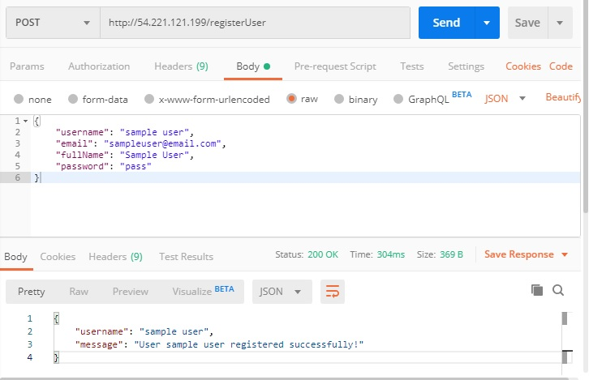

Here is how registerUser looks in postman on **successfully registering a user**.

At the very top of the picture, we can see it is using POST with the correct url.

In the middle of the picture, that is the JSON being passed **into** the API call.

At the bottom of the picture, that is what the API call returns. For register user, on successful calls, it will always return username and message.

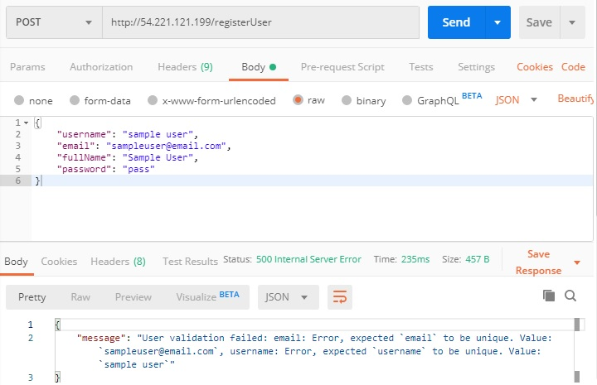

Here is what the API call returns when both username and email are already in the database. It will return something similar if just one of them already exist in the database.

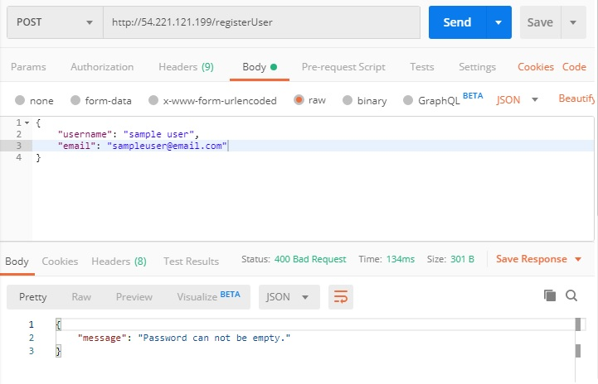

Here is what the API call returns when one of the required fields in the JSON input is missing.

**Note:** Most API calls have a similar setup. It will only return message when there is an error. If it is successful, it will return something AND message. The only exceptions are getAllUsers and getAllRoutines. These two exceptions will return a JSON with a users or routines array when successful.

Here are some more examples:

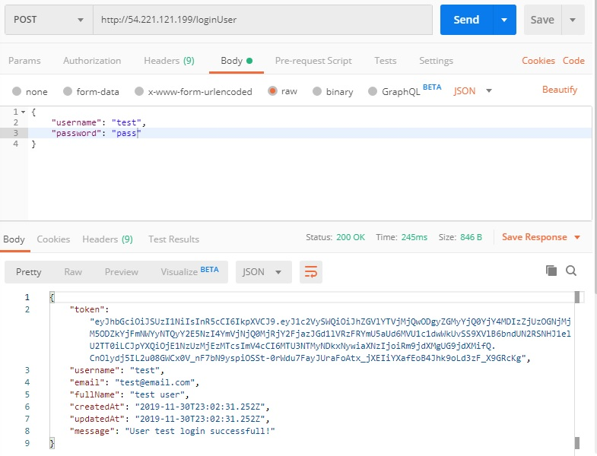

Here is a successful login.

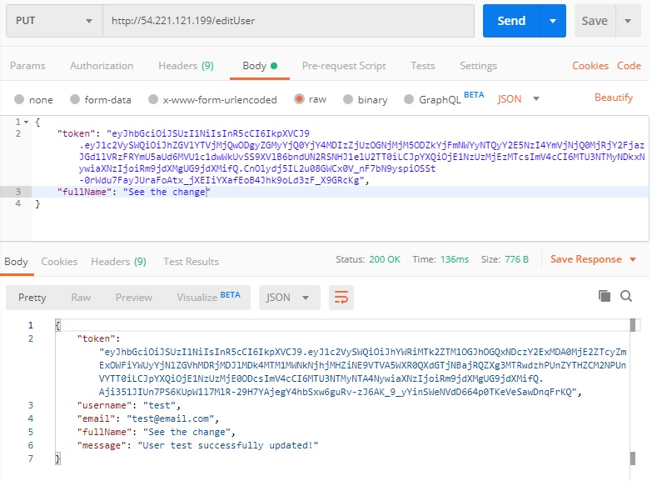

Here is a successful edit. Notice the HTTP request is PUT.

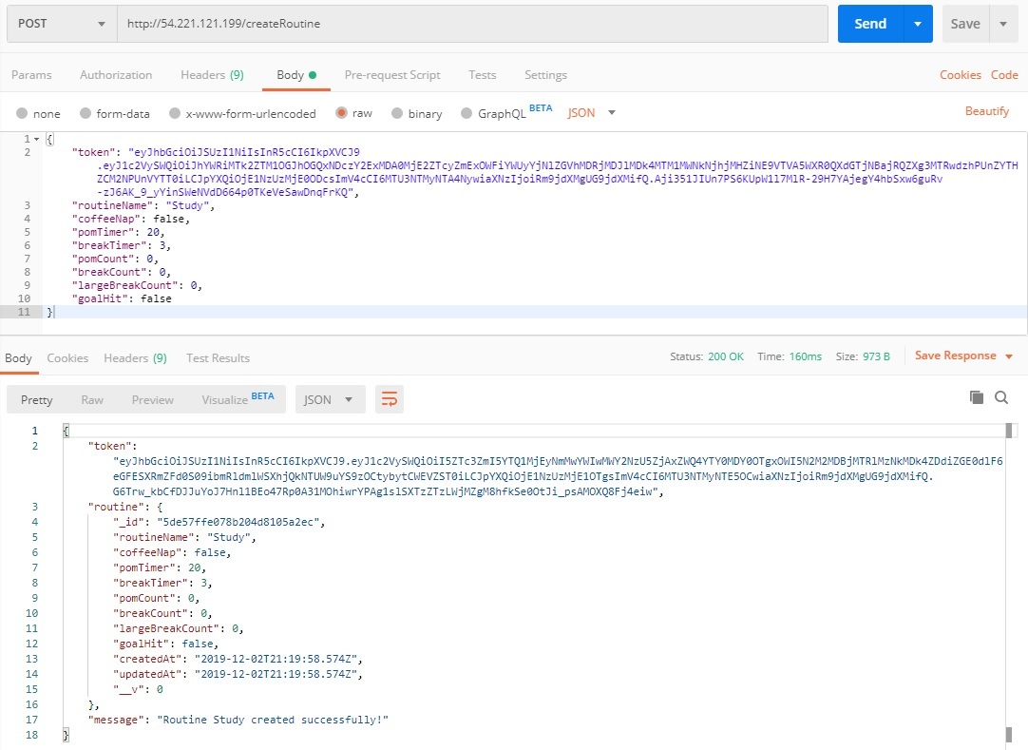

Here is a successful routine creation.

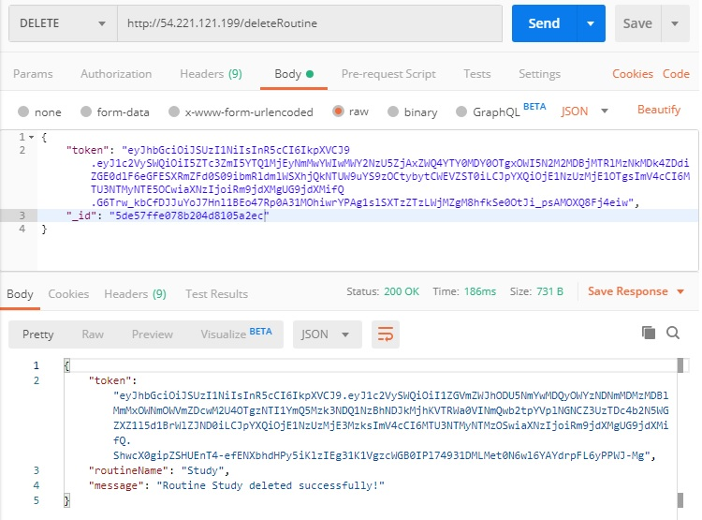

Here is a successful routine deletion. Notice that the HTTP request is DELETE